Encoding:

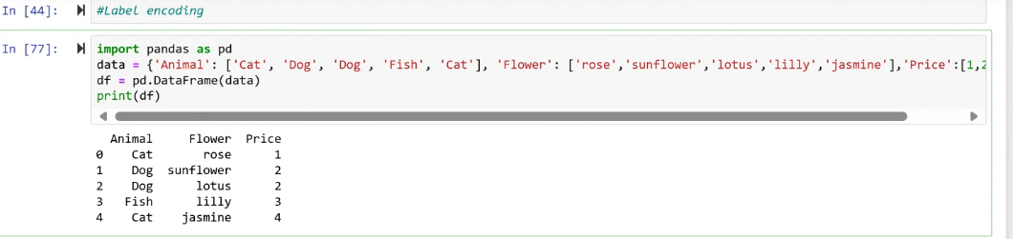

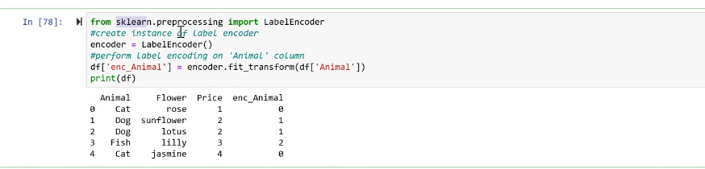

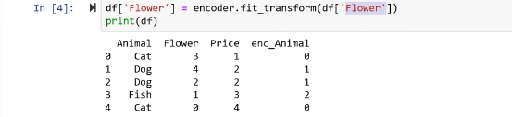

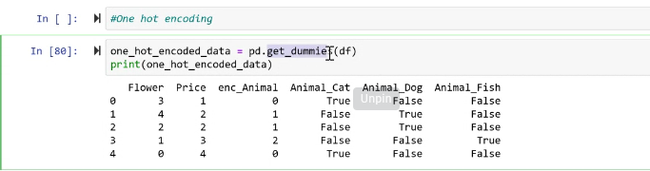

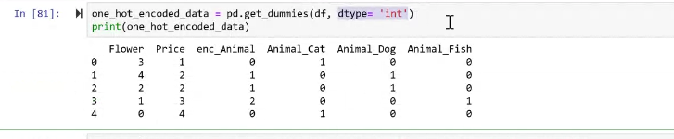

**Convert all true or false into 0 and 1**

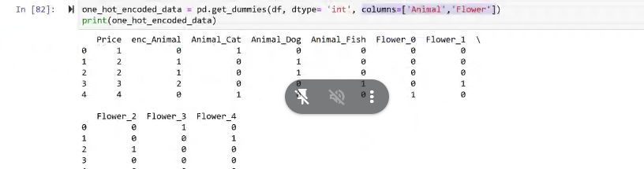

**Normalization:**

**Min max**

**Z normalization**

